Design and Implementation of Smart Floor Cleaner using Arduino Controller

V. Kalai Rajan,
Assistant Professor in EEE Department,
Kongunadu College of Engineering and Technology,
Thottiyam, Trichy, Tamilnadu, India.
kalairajaneee@gmail.com

J.Karthikeyan,
Assistant Professor in EEE Department,
Kongunadu College of Engineering and Technology,
Thottiyam, Trichy, Tamilnadu, India.
karthikeyan249@gmail.com

Dr.T.Sengolrajan,
Associate Professor in EEE Department,
Kongunadu College of Engineering and Technology,
Thottiyam, Trichy, Tamilnadu, India.
sengolmaha@gmail.com

Abstract-- The robots are has been used for various cleaning purposes. Robots have various cleaning expertise like mopping, picking up the waste, wet floor cleaning, dry vacuum cleaning etc., Depending on the cleaning mechanism, these robots may have some advantages and disadvantages. Smart floor cleaning (SFC) robot has been designed for home and office environments. This robot on receiving the commands from the android device cleans a area using a cleaning pad on the floor. After cleaning the wet floor, it can drain the dirty water into the required container as per the commands given to it. The robotic arm is used for efficient and effective wet floor cleaning purpose. This system can also be used to pick up the objects and carry them within the Bluetooth range. The proposed system is a manual system because it is controlled by android application which is operated by human. The proposed system functioning is entirely depended on the commands that are received from the android application.

Keywords—Power supply, pump module, Arduino Microcontroller based Smart Controller, Bluetooth
.
- INTRODUCTION

In the recent years, robots have been used for various cleaning purposes. Robots have various cleaning expertise like mopping, picking up the waste, wet floor cleaning, dry vacuum cleaning etc., Depending on the cleaning mechanism, these robots may have some advantages and disadvantages. Smart floor cleaning robot has been designed for home and office environments. This robot on receiving the commands from the android device cleans a area using a cleaning pad on the floor. After cleaning the wet floor, it can drain the dirty water into the required container as per the commands given to it. The robotic arm is used for efficient and effective wet floor cleaning purpose. This system can also be used to pick up the objects and carry them within the Bluetooth range. The proposed system is a manual system because it is controlled by android application which is operated by human. The proposed system functioning is entirely depended on the commands that are received from the android app.
Robot is an electromechanical machine and used for various purposes in industrial and domestic applications. Robot appliances are entering in the consumer market, since the introduction of I-Robots. Initially the main focus was on having a cleaning device. As the time pass on many improvements were made and more efficient appliances were developed. In early 2010, a new automatic floor cleaner robot “Mint” was developed by Jen Steffen. Detachable clothes were attached for sweeping and mopping purposes. For tracking mint used the GPS-like indoor localization system. In this paper, a floor cleaner robot based on ATMEGA328 has been developed. This cleaner robot is an electric home appliance, which works in Automatic mode .Unlike existing floor cleaner robots this is not a vacuum cleaner robot; but it performs sweeping and mopping operation. Detachable mop is used for mopping. It works on multi-power supply i.e., 12V dc supply or single phase AC supply. In the automatic mode, robot performs all operations itself. Our proposed system has the added advantage of displaying the time elapsed during its operation and the proportionate cost so that it can be used for commercial purposes also. Firstly robot starts, and then it moves forward and performs cleaning action. For user convenience automatic water sprayer is attached which automatically sprays water for mopping, therefore no need to attach wet cloth again and again for mopping. Motor driver circuit have been used to drive the motors. Four motors have been used to perform respective operations like to move the robot, for water pump, for cleaner. Relays have been used to drive the water pump and cleaner motor. LM293D IC has been used to drive wheel motor.

- LITERATURE SURVEY

Yusuf Abdullahi Badamasi, The Working Principle of An Arduino, Electronics, Computer and Computation (ICECCO), 2014 11th International Conference on 29 Sept.-1 Oct. 2014. In this paper, we are learned the working principle of an arduino. These days many people try to use the arduino because it makes things easier due to the simplified version of C++ and the already made Arduino microcontroller (atmega328 microcontroller) [12] that you can program, erase and re program at any given time. In this paper we will discuss the hardware components used in the arduino board, the software used to program it (Arduino board) with the guide on how to write and construct your own projects, and a couple of examples of an arduino project, This will give you the overall view of an arduino uno, that after reading this paper you will get the basic concept and use of an arduino uno controller. Andrew Ziegler, Christopher John Morse, Duane L. Gilbert, Jr., Andrew Jones, “Autonomous surface cleaning robot for dry cleaning,” U.S. Patent 8782848 B2, July 22, 2014. With the advancement of technology, robots are getting more attention of researchers to make life of mankind comfortable. This paper presents the design, development and fabrication of prototype Smart Floor Cleaning Robot (CLEAR) using IEEE Standard 1621 (IEEE Standard for User Interface Elements in Power Control of Electronic Devices employed in Office/Consumer Environments).

- SMART FOOR CLEANER USING ARDUINO AND BLUETOOTH CONTROLLER

In this paper, an autonomous robot for floor cleaning application is proposed. It is capable of performing mopping, cleaning tasks. The proposed model “Design and Implementation of Smart Floor Cleaning Robot using Android App” shows fig 2 for better understanding of the proposed work. This block diagram consists of 12v DC motor, L293D IC, Bluetooth module, cleaning mechanism and Arduino UNO. The power supply is given to the Arduino UNO as well as to relay. The robotic arm used here consists of 5 dc motors where 4 dc motor is used for moving robotic Forward Reverse, left, right and last dc motor is used to rotate arm completely for cleaning. Here we use L239D drivers for driving dc motors to move in forward and backward direction. Bluetooth module is used to control the robot using mobile phone application within a range.
This wireless system consists of a transmitter application that runs on an android mobile app which allows the robot to follow commands given by the user through the transmitter app. The proposed robot consists of Arduino UNO controller which has fourteen digital input/output pins, robotic arm with cleaning pad for efficient cleaning. The Arduino UNO, on receiving the commands from android device through Bluetooth receiver, decodes the given commands and controls the motors to achieve the desired path and direction.
This smart cleaner module is leads to make clean and healthy society in our country. We can install it for any public environment. The proposed scheme has been modelled for robust implementation in the Indian situation.

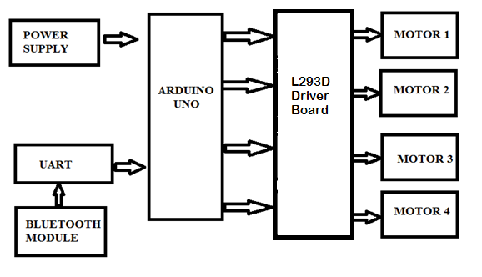

Fig 1: Block diagram of proposed Smart Foor Cleaner

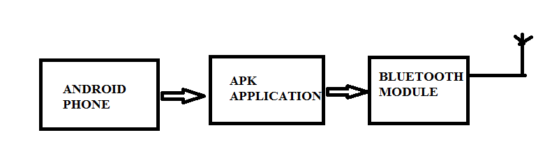

Fig 2: Transmitter
A. Arduino Uno
In our project arduino controller is used to control the motor and pumps to drive the car and clean the floor. The spray system of water also controlled by controller. The Arduino UNO is an open-source microcontroller board based on the Microchip ATmega328P microcontroller and developed by Arduino.cc. The board is equipped with sets of digital and analog input/output (I/O) pins that may be interfaced to various expansion boards (shields) and other circuits. The board has 14 Digital pins, 6 Analog pins, and programmable with the Arduino IDE (Integrated Development Environment) via a type B USB cable. It can be powered by a USB cable or by an external 9 volt battery, though it accepts voltages between 7 and 20 volts. It is also similar to the Arduino Nano and Leonardo. The hardware reference design is distributed under a Creative Commons Attribution Share-Alike 2.5 license and is available on the Arduino website. Layout and production files for some versions of the hardware are also available. "Uno" means one in Italian and was chosen to mark the release of Arduino Software (IDE) 1.0. The Uno board and version 1.0 of Arduino Software (IDE) were the reference versions of Arduino, now evolved to newer releases. The Uno board is the first in a series of USB Arduino boards, and the reference model for the Arduino platform. The ATmega328 on the Arduino Uno comes preprogrammed with a boot loader that allows uploading new code to it without the use of an external hardware programmer. It communicates using the original STK500 protocol. The Uno also differs from all preceding boards in that it does not use the FTDI USB-to-serial driver chip. Instead, it uses the Atmega16U2 (Atmega8U2 up to version R2) programmed as a USB-to-serial converter.
The Arduino Uno R3 is a microcontroller is used in our project to integrate and control the functions of all equipment’s like LCD, Bluetooth. The Arduino Uno R3 is a microcontroller board based on the ATmega328. It has 14 digital input/output pins (of which 6 can be used as PWM outputs), 6 analog inputs, a 16 MHz crystal oscillator, a USB connection, a power jack, an ICSP header, and a reset button. It contains everything needed to support the microcontroller; simply connect it to a computer with a USB cable or power it with a AC-to-DC adapter or battery to get started. The Uno differs from all preceding boards in that it does not use the FTDI USB-to-serial driver chip.
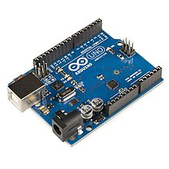

Fig 3: Arduino Uno
B. Sensors
In our project we were designed fully automated floor cleaner system with bluetooth setup. For this automated system we used multiple sensors, one is PIR sensor another one is Ultrasonic sensor. Which are used to sense the object or human near the cleaner path and stop the motors of wheels the after clear the object cleaner moves ahead. PIR and ultrasonic sensors are used in this paper.
A PIR (Passive Infrared) sensor is a motion detector which detects the heat (infrared) emitted naturally by humans and animals. When a person in the field of vision of the sensor moves, the sensor detects a sudden change in infrared energy and the sensor is triggered (activated). They are commonly used in security lighting and alarm systems in an indoor environment. The PIR sensors have a range of approximately 6 meters, depending on conditions.The sensor adjusts to slowly changing conditions that occur normally within the environment, but shows a high-output response when a sudden change takes place.
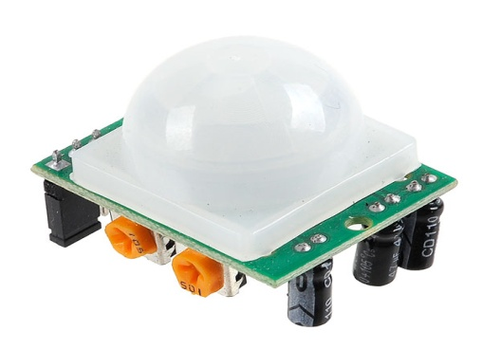
Fig 4: PIR sensor

Ultrasonic sensors are devices that use electrical–mechanical energy transformation to measure distance from the sensor to the target object. Ultrasonic waves are longitudinal mechanical waves which travel as a sequence of compressions and rarefactions along the direction of wave propagation through the medium. Apart from distance measurement, they are also used in ultrasonic material testing (to detect cracks, air bubbles, and other flaws in the products), Object detection, position detection, ultrasonic mouse, etc.
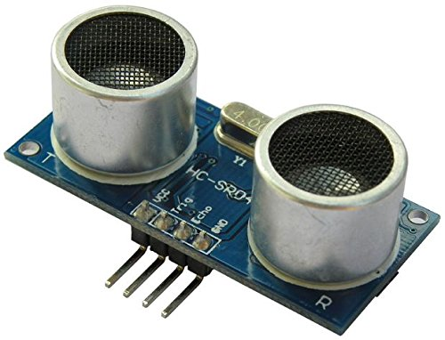
Fig 5: Ultrasonic sensor

C. Geared DC motors
A DC motor is any of a class of rotary electrical machines that converts direct current electrical energy into mechanical energy. The most common types rely on the forces produced by magnetic fields. Nearly all types of DC motors have some internal mechanism, either electromechanical or electronic, to periodically change the direction of current flow in part of the motor. DC motors were the first form of motor widely used, as they could be powered from existing direct-current lighting power distribution systems. A DC motor's speed can be controlled over a wide range, using either a variable supply voltage or by changing the strength of current in its field windings. Small DC motors are used in tools, toys, and appliances. The universal motor can operate on direct current but is a lightweight brushed motor used for portable power tools and appliances. Larger DC motors are currently used in propulsion of electric vehicles, elevator and hoists, and in drives for steel rolling mills. The advent of power electronics has made replacement of DC motors with AC motors possible in many applications.

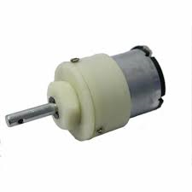
Fig 6: Geared DC motor

- D. Pumps

ESPs are pumps made of dynamic pump stages or centrifugal pump stages. It gives the internal schematic of a single-stage centrifugal pump. It is used to spray the solution and water.
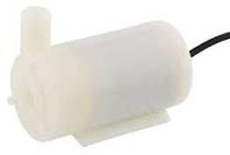
Fig 7: Pump module

- E. Motor Drive
A motor drive, in the field of photography, is a powered film transport mechanism. Historically, film loading, advancing, and rewinding were all manually driven functions. It is used to control the operation of the cleaner wheels

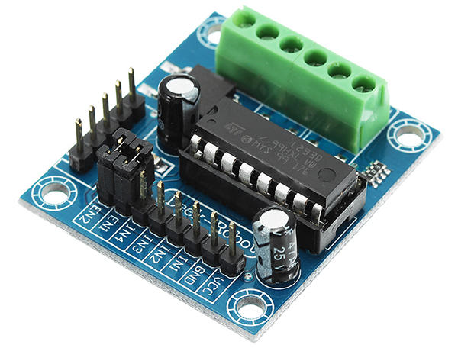
Fig 8: L239DC Motor driver

- F. Lead Acid Battery
An electric battery is a device consisting of one or more electrochemical cells with external connections provided to power electrical devices such as flashlights, smart phones, and electric cars. When a battery is supplying electric power, its positive terminal is the cathode and its negative terminal is the anode.
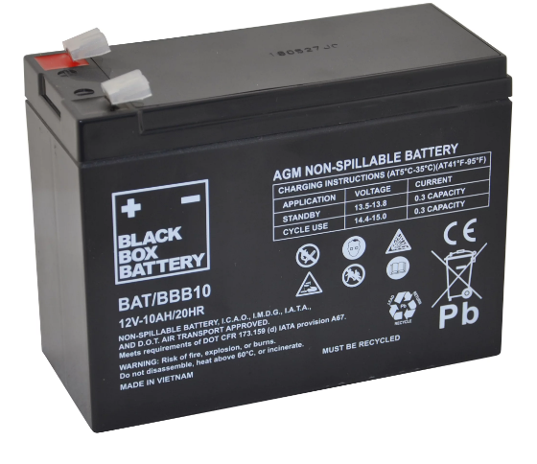
Fig 9: Lead acid battery
- G. Wheels
A wheel is a circular component that is intended to rotate. The wheels are controlled forward and reverse by arduino programming and bluetooth module with the help of driver circuit.
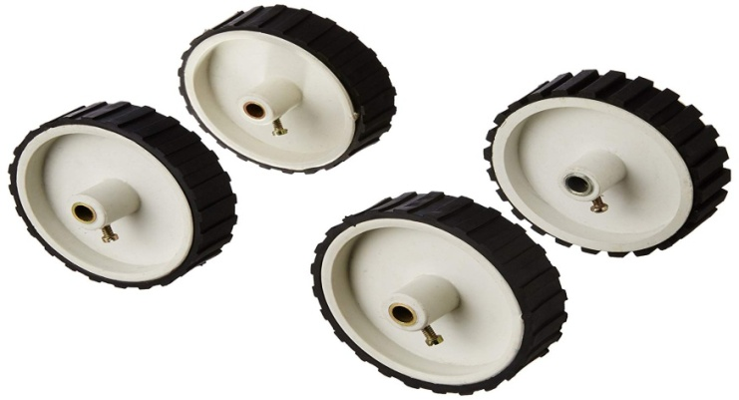
Fig 10: Wheels

H. HC-05 Bluetooth Module
HC‐05 module is an easy to use Bluetooth SPP (Serial Port Protocol) module, designed for transparent wireless serial connection setup. The HC-05 Bluetooth Module can be used in a Master or Slave configuration, making it a great solution for wireless communication.
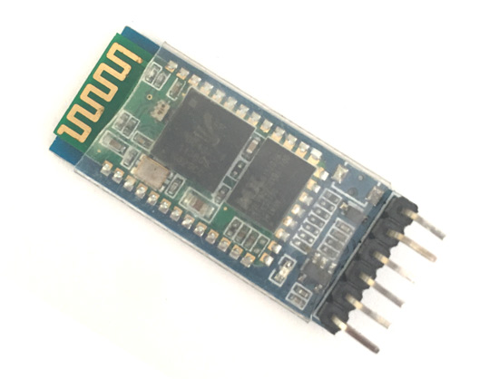
Fig 11: Bluetooth Module

- SOFTWARE IMPLEMENTATION

A. Embedded Programming
An embedded system is an application that contains at least one programmable computer (typically in the form of a microcontroller, a microprocessor or digital signal processor chip) and which is used by programmer to do particular function.
In this project arudino programming is used to control cleaner and display the outputs. Codes are installed in arduino UNO controller to control the cleaner.

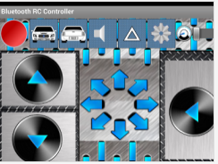

Fig 12: Bluetooth mobile application

B. Code for Smart Floor Cleaner:
char t;
void setup()
{
pinMode(13,OUTPUT); //left motors forward
pinMode(12,OUTPUT); //left motors reverse
pinMode(11,OUTPUT); //right motors forward
pinMode(10,OUTPUT); //right motors reverse
pinMode(9,OUTPUT); //Led
Serial.begin(9600);
}
void loop()
{
if(Serial.available()){
t = Serial.read();
Serial.println(t);
}
if(t == 'F')
{ //move forward(all motors rotate in forward direction)
digitalWrite(13,HIGH);
digitalWrite(11,HIGH);
}
else if(t == 'B')
{ //move reverse (all motors rotate in reverse direction)
digitalWrite(12,HIGH);
digitalWrite(10,HIGH);
}
else if(t == 'L')
{ //turn right (left side motors rotate in forward direction, right side motors doesn't rotate)
digitalWrite(11,HIGH);
}

else if(t == 'R')
{ //turn left (right side motors rotate in forward direction, left side motors doesn't rotate)
digitalWrite(13,HIGH);
}
else if(t == 'W')
{ //turn led on or off)
digitalWrite(9,HIGH);
}
else if(t == 'w')
{
digitalWrite(9,LOW);
}
else if(t == 'S')
{ //STOP (all motors stop)
digitalWrite(13,LOW);
digitalWrite(12,LOW);
digitalWrite(11,LOW);
digitalWrite(10,LOW);
}
delay(100);
}
- PROTOTYPE MODULE OF AEMS

Floor Cleaner Module
In this system we are design smart floor cleaning robot that allows cleaning the floor by giving instructions to the robot. This robot makes floor cleaning process easy and fast utilizing a wireless robotic cleaning system. This wireless system consists of a transmitter application that runs on an android mobile app which allows the robot to follow commands given by the user through the transmitter app. The proposed robot consists of arduino UNO controller which has fourteen digital input/output pins, robotic arm with cleaning pad for efficient cleaning. The arduino UNO, on receiving the commands from android device through bluetooth receiver, decodes the given commands and controls the motors to achieve the desired path and direction. It can control by mobile using bluetooth module and semi automatic cleaning control. First this module can do the dry cleaning and the wet cleaning process. It reduces the cleaning time to the half. This proposed system is a portable low cost module and simple control key used to make this system user friendly.
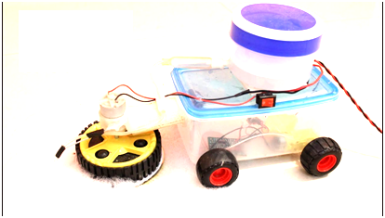

Fig 13. Prototype module of SFC

VI. CONCLUSION

Thus the smart floor cleaner system is implemented with two modules one is spray and cleaner module and automatic driver module. This research facilitates efficient floor cleaning. Since in project the floor cleaner is incorporated with different devices like DC motor, HC-05, L239D etc., so it will be easy to handle it also saves time and will work automatically for cleaning purpose at homes and offices. With simple program, the cleaner will be able to cover large floor areas as well as find its way into and out of small corners. As the cleaner traverses the room, the sweeper installed in it will manage to pick up a significant amount of dirt. Manual Sweeping might not be that effective as it will not be picking up everything in as it is not in sight but using the automatic floor cleaner it can be done easily.

REFERENCES

[1] Andrew Ziegler, Christopher John Morse, Duane L. Gilbert, Jr., Andrew Jones, “Autonomous surface cleaning robot for dry cleaning,” U.S. Patent 8782848 B2, July 22, 2014.
[2] Andrew Ziegler, Duane Gilbert, Christopher John Morse, Scott Pratt, Paul Sandin, Nancy Dussault, Andrew Jones, “Autonomous surface cleaning robot for wet and dry cleaning,” U.S. Patent 7389156 B2, June 17, 2008.
[3] Buck, 'The Best Robot Vacuums of 2015 | Top Ten Reviews', TopTenREVIEWS, 2014. [Online]. Available: http://robot-vacuumreview.toptenreviews.com/.
[4] Dyson.com, 'Latest Dyson Vacuum Cleaner Technology | Dyson.com', 2015.[Online]. Available: http://www.dyson.com/vacuum-cleaners.aspx.
[5] Dyson 360 Eyeâ„¢ robot, 'Dyson 360 Eyeâ„¢ robot', 2015.[Online].Available: https://www.dyson360eye.com/.
[6] Harvey Koselka, Bret A. Wallach, David Gollaher,“Autonomous floor mopping apparatus,” U.S. Patent 6741054 B2, May 25, 2004.
[7] IEEE Standard for User Interface Elements in Power Control of Electronic Devices employed in Office/Consumer Environments, IEEE Standard 1621,2004(R2009).
[8] Irobot.com, 'iRobot Corporation: We Are The Robot Company', 2015. [Online]. Available: http://www.irobot.com/.
[9] Joseph L. Jones, Newton E. Mack, David M. Nugent, Paul E. Sandin, “Autonomous floor-cleaning robot,” U.S. Patent 6883201 B2, April 6, 2005.
[10] Michael Dooley, James Philip Case, and Nikolai Romanov,“System and method for autonomous mopping of a floor surface,” U.S. Patent 8 892 251 B1, November 18, 2014.
[11] Neato, 'Neato Robotics | Smartest, Most Powerful, Best Robot Vacuum', 2015.[Online]. Available: http://www.neatorobotics.com/.
[12] Yusuf AbdullahiBadamasi, The Working Principle Of An Arduino, Electronics, Computer and Computation (ICECCO), 2014 11th International Conference on 29 Sept.-1 Oct. 2014.

